Linking Social Network to Education:
The Potentials and Challenges

Ilju RHA
Seoul Nat’l University
Korea

Despite the relatively short history of Social Network Sites or Services (SNS), it has quickly gained popularity with more than seven hundred million users all over the globe. The SNS emerged as one of the strongest cultural influences for the contemporary society. The SNS would provide both chances and challenges for Education. The main purpose of the article was to explore the way education react and adapt to the emergence of social network and SNS. It tried to provide major theoretical grounds that bridge education and social network. In the due process, the researchers have examined the curriculum and instructional design process of education from the perspective of disruptive and sustainable aspect of SNS technology. Consequently, four major theoretical grounds were identified and reviewed: Gibson's theory of affordance, Vygotsky's social constructivism, Rha's human visual intelligence theory, and the network theory. By investigating these theories, the educational potentials of social network and SNS were emerged. The SNS was viewed as a new medium with abundant potentials of expanding the learning space, empowering the affective aspects of learning, and facilitating the formation of group intelligence. Finally, some future implications and challenges of SNS were suggested.

Keywords: Social network, Social media, Social constructivism, Affordance, Human visual intelligence, Network theory
Introduction

The pioneers of the field like Durkheim and McLuhan had already foreseen the emergence of social network resulting from the combination of various technologies such as human creativity and the development of electricity. Durkheim insists that ‘social phenomenon’ is the reality constructed by the interaction among individuals, and that it progresses through organic solidarity which accepts individual specialization (Freeman, 2004). In his work ‘Understanding Media’, Marshall McLuhan (1964) anticipated that media would not stay limited to personal uses, but would continue to cultivate social relationships. He perceived electricity as playing a major role in expanding and integrating humanity for electricity makes all the other electric media possible. The nature of electricity is to connect things, even beyond the spatial dimension. It connects a machine to a machine and a person to others. So it seems that social network has emerged as a product of people's basic social needs and computer communication technology.

The Reality of Social Network

The history of social network

The history of social network is not too long. The first social networking sites or services (SNS) launched in 1997, and since then only 14 years have passed. Nevertheless, the change it has brought about is enormous. SNS bean with SixDegrees.com in 1997, where a user could upload his profile, search for friends, and share profiles with friends (boyd & Ellison, 2008). But SixDegrees.com discontinued its service in 2000. Although the number of users was increasing, they had difficulty expanding its system large enough to sustain all the users at that time (boyd & Ellison, 2008).
Table 1
D-aspects and S-aspects of SNS affecting to the four components of education curriculum
Four components  of educational  curriculum | D-aspects | S-aspects
Educational  objective | ▫ Change to selecting educational objectives  ▫ More considerations required while selecting educational objectives | Immediate  reflection  of learner's  needs
Content | ▫ Dramatic change to the construction of content  ▫ Subjects that need to be taken down | Diversity of  content
Process of  learning experience | ▫ Dramatic change to teaching- learning situation | Diversity of learning  Experiences
Evaluation | ▫ Change to evaluation of academic achievement  ▫ Evaluation of problem solving and higher order thinking skills | Diversity of  evaluation methods

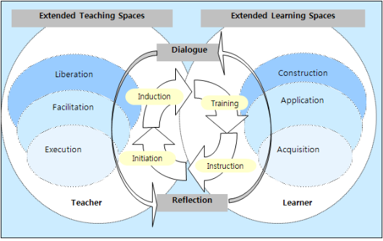
Figure 1. Extended learning spaces in e-learning (Jung & Latchem, 2009)

References

Bhola, H. S. (1988). The CLER model of innovation diffusion, planned change, and development: A conceptual update and applications. Knowledge, Technology & Policy, 1(4), 56-66.
Bhola, H. S. (1982). Planning change in education and development: The CLER model in the context of a mega model. Viewpoints in Teaching and Learning, 58(4), 1-35.
Freeman, L. C. (2004). The Development of Social Network Analysis: A study in the sociology of science. Empirical Press.
Gredler, M. E. (1997). Learning and Instruction: Theory Into Practice (3rd ed). Prentice-Hall.
Greenhow, C., & Robelia, B. (2009). Old communication, new literacies: Social network sites as social learning resources. Journal of Computer Mediated Communication, 14(4), 1130–1161.

Ilju RHA
Professor, Dept. of Education, College of Education, Seoul National University.
Interests: Educational Technology, Instructional Design, Human Visual Intelligence
E-mail: iljurha@snu.ac.kr, Homepage: http://iwind.com

Received: April 7, 2012 / Peer review completed: April 23, 2012 / Accepted: April 29, 2012

